TASK # 04
Zain Ali (323)
AI (Lab)
Question 01:
Compute g, h and f values for the first three expansions by hand. Use the supplied campus graph, heuristic, start S and goal G. For each of the first three expansions, write the selected node, g, h and f, plus all remaining frontier entries. Show each arithmetic calculation and explain why the next node is selected. Use successor order and the stated queue tie-breaking consistently.
What I did:
This code implements the **A\* search algorithm** to find the lowest-cost path from a starting node to a target node in a weighted graph. `G` stores the graph connections and their costs, while `h` stores the heuristic value for each node, estimating the remaining distance to the goal. The `astar(s, t)` function creates a priority queue containing the total estimated cost `f = g + h`, where `g` is the cost from the start node and `h` is the heuristic cost to the goal. It repeatedly removes the node with the smallest `f` value, checks whether it is the target, and otherwise adds its neighbouring nodes to the queue with their updated costs and paths. Finally, the program prints the selected path and its total cost from `A` to `G`.
Code screenshot :
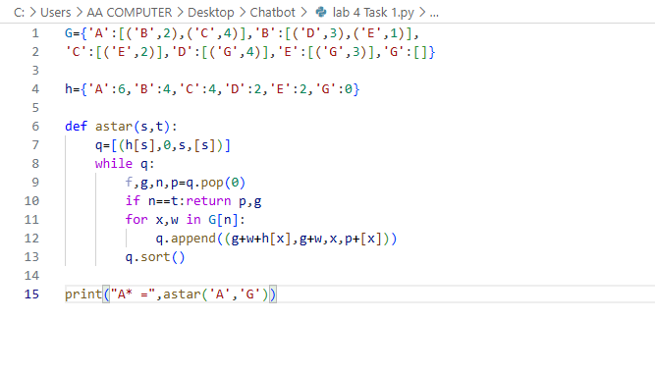
Code Explanation :
This code uses the **A\* search algorithm** to find a path from node `A` to node `G` in a weighted graph. The dictionary `G` represents the graph: each node contains its neighboring nodes and the cost of reaching them. For example, `A` can reach `B` with cost `2` and `C` with cost `4`. The dictionary `h` contains heuristic values, which estimate the remaining cost from each node to the goal node `G`. The function `astar(s, t)` starts with node `s` and stores each option in the list `q` using the formula **f(n) = g(n) + h(n)**, where `g(n)` is the cost from the start node and `h(n)` is the estimated cost to the goal. The queue is sorted so that the node with the smallest estimated total cost is selected first. The code continues expanding nodes until it reaches the target node `t`. It also stores the complete path in `p`. In this example, the output is:

```text
A* = (['A', 'B', 'E', 'G'], 6)
```

This means that the selected path is **A → B → E → G**, and the total path cost is **6**.
Code Running Screenshot :
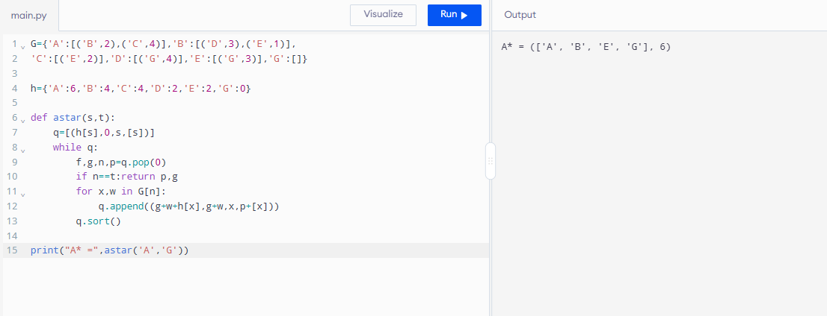
Question 02:
Run A* and UCS on the same graph and record expanded nodes. Keep the weighted graph and endpoints identical. Run the supplied heuristic and a zero-heuristic UCS control. Record returned path, independently summed path cost, processed-node trace and expansion count. Use the same counting convention in both runs; explain any stale-entry or goal-counting differences.
What I did:
This code compares **A\*** and **Uniform Cost Search (UCS)** using the same weighted graph. The `G` dictionary stores each node’s neighboring nodes and the cost of reaching them, while `H` stores heuristic values for A\*. The `search(s, t, h)` function uses Python’s `heapq` priority queue to select the node with the smallest value of `f = g + h`, where `g` is the actual cost from the start node and `h` is the estimated cost to the goal. The `seen` list records the nodes that have already been expanded, and the search stops when it reaches the target node `G`. In the first print statement, the actual heuristic values are used, so the algorithm performs A\* search. In the second statement, all heuristic values are changed to zero, making `f = g`; therefore, the algorithm performs UCS. Both algorithms find a path with a total cost of **6**, but they may expand different nodes because A\* uses heuristic guidance while UCS considers only the actual path cost.
Code screenshot :

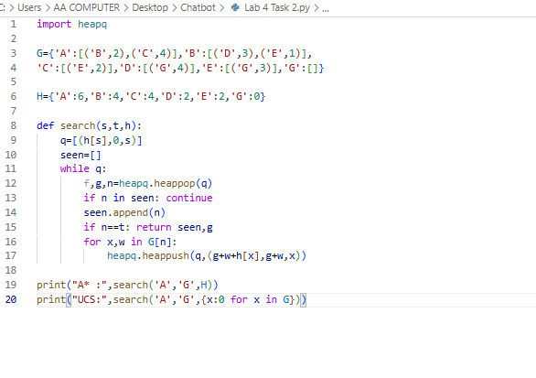
Code Explanation :
This code compares **A\*** and **Uniform Cost Search (UCS)** on the same weighted graph. The `heapq` module is used to create a priority queue, which always removes the node with the lowest priority. The dictionary `G` stores the graph connections and edge costs, while `H` stores heuristic values for each node. In the `search(s, t, h)` function, `q` stores tuples in the form `(f, g, node)`, where `g` is the actual cost from the start node and `f = g + h[node]` is the estimated total cost. The `seen` list records nodes that have already been expanded, and `if n in seen: continue` prevents repeated processing. When the goal node is found, the function returns the expanded nodes and the total cost. The first print statement uses the original heuristic values, so it performs A\* search. The second print statement uses `{x:0 for x in G}`, which changes every heuristic value to zero; therefore, `f = g` and the algorithm becomes UCS. For this graph, both algorithms reach `G` with a total cost of **6**, but A\* is guided by heuristic values and usually expands fewer unnecessary nodes. Note that this code returns the **expanded-node order**, not the complete path itself.

Code Running Screenshot :
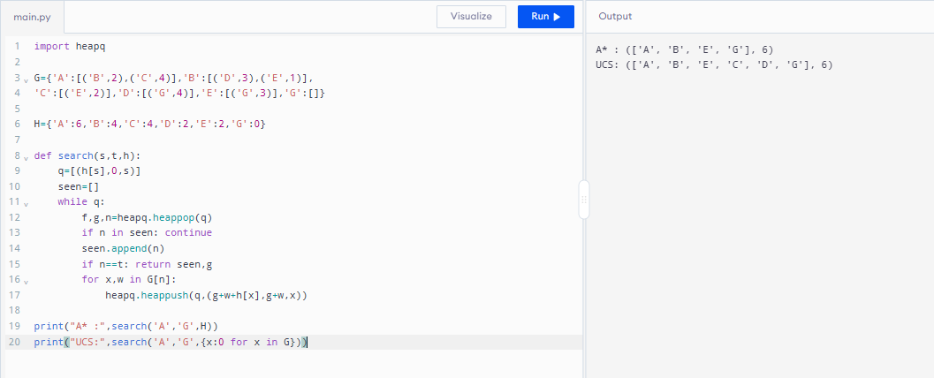
Question 03:
Deliberately change one heuristic value to an overestimate and discuss whether the returned result changes. Change one heuristic value only, record its original and modified values, and compare it with that node’s true remaining cost on this small graph. Use h(C)=10 as a reproducible example or justify an equivalent experiment. Rerun, report whether path/cost/count changes, and explain why an overestimate can remove the optimality guarantee even when a particular run appears unchanged.

What I did:
This code performs a **heuristic experiment with the A\* search algorithm**. The dictionary `G` represents the weighted graph, while `H` contains the heuristic values for each node. The `astar(start, goal, h)` function uses a priority queue created with `heapq`, where each item is stored as `(f, g, node, path)`. Here, `g` is the actual cost from the start node, `h` is the estimated cost to the goal, and `f = g + h` is the total estimated cost. The algorithm always expands the node with the smallest `f` value and adds the selected node to the current path. First, the program runs A\* using the original heuristic values and normally finds the path **A → B → E → G** with a total cost of **6**. Then, it changes the heuristic value of node `B` from `4` to `10` and runs A\* again. Because the modified heuristic overestimates the remaining cost from `B`, A\* may avoid the better route and select **A → C → E → G**, whose cost is **9**. This experiment shows that an inaccurate or overestimated heuristic can cause A\* to return a non-optimal path.

Code screenshot :
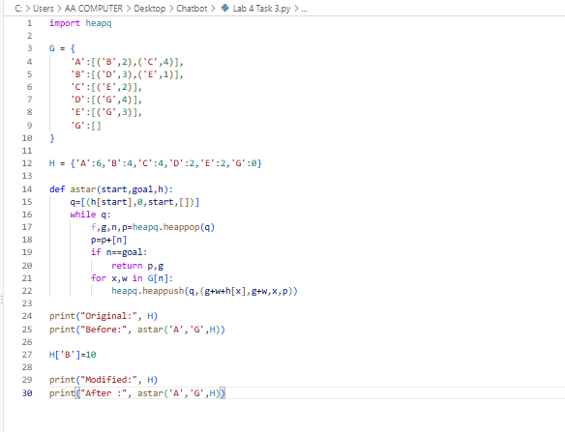
Code Explanation :
This code demonstrates an **A\* heuristic experiment** on a weighted graph. The dictionary `G` stores each node’s neighboring nodes and the cost of reaching them, while dictionary `H` stores the heuristic value of each node. The `astar()` function uses `heapq` as a priority queue and stores each option as `(f, g, node, path)`, where `g` is the actual cost from the start node, `h` is the estimated cost to the goal, and `f = g + h` is the total estimated cost. The algorithm removes the node with the smallest `f` value, adds it to the current path, and continues until it reaches the goal node `G`. First, it runs with the original heuristic values and prints the best path before modification. Then, `H['B']=10` changes node `B`’s heuristic from `4` to `10`. The algorithm is run again with this modified heuristic, allowing us to compare the results before and after the change. With the original heuristic, the result is normally **A → B → E → G** with cost **6**. After changing the heuristic of `B`, the algorithm may choose **A → C → E → G** with cost **9**, showing that an overestimated heuristic can make A\* select a non-optimal path.
Code Running Screenshot :
